1. Create AWS and GitHub Account  
   2) Install VSCode and GIT Bash  
     
   Read through What is DevOps and Phases  
     
   Understand Linux OS (Kernel, Distros)

**1a. AWS Account**

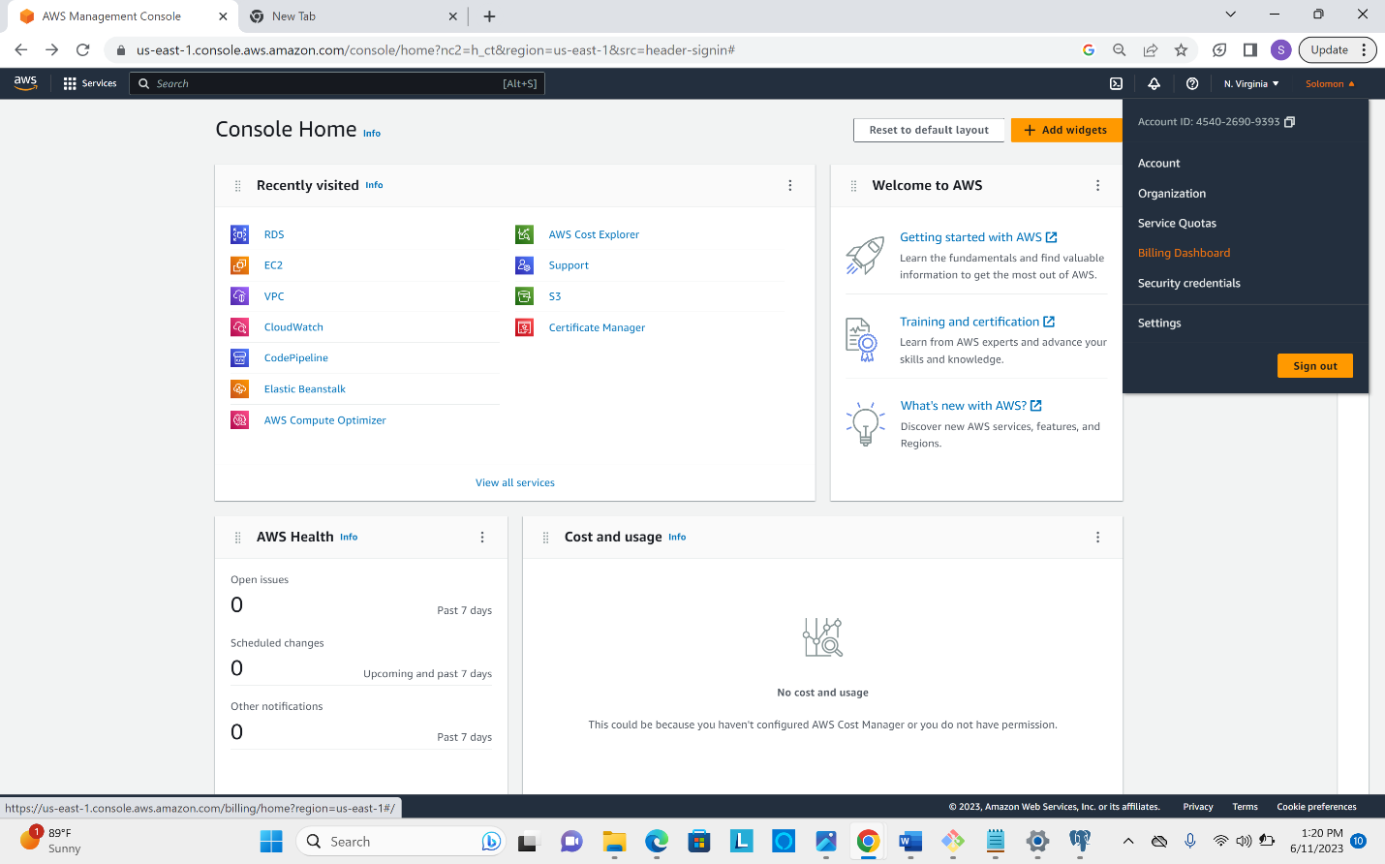

**1b. Git Hub Account**

